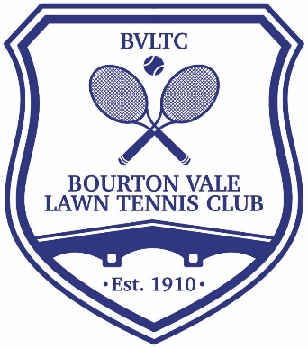
CODE OF CONDUCT FOR MEMBERS

This Code of Conduct sets out what the Club regards as good practice on and off the tennis courts under normal circumstances so every member is clear as to what is expected of them to create an enjoyable, safe playing environment for all.
- Show respect and courtesy to other players and visitors of all ages
- Welcome new members and players to the Club irrespective of their age or ability
- Respect club property and facilities – leave courts and clubhouse clean and tidy, take rubbish home
- Courts are intended exclusively for tennis related activities. Dogs, footballs, skateboards, scooters, bikes or anything other than tennis equipment are not permitted on the tennis courts.
- Tennis clothes are not required but please dress respectably – tops or T-shirts to be worn at all times
- Please ensure you are wearing appropriate footwear with non-marking soles to protect the courts
- Be aware that others may need to cross your court to access their own court and facilitate that where possible
- Do not walk onto another court during a game. Wait for the conclusion of the point or until you are invited to cross and do so as quickly as possible
- Close the gate behind you
- If your ball goes onto another court wait for a break in play before requesting its return. If a ball strays onto your court wait until players are ready before hitting it back to the server’s end
- Don’t walk or play behind or alongside the courts when a game is in progress and keep conversation and noise to a minimum to avoid distracting players on another court
- It is polite to leave the court together at the end of the match
- Encourage other players rather than criticising them
- Only call line calls on your side of the net. Call clearly on the basis of what you honestly believe to be correct. If you aren’t sure or didn’t see the ball clearly the ball was good and the point must be given in favour of the opponent. If occasionally you have serious doubt over a line call ask your opponents politely if they are certain about the accuracy of their call. If they are, move on to the next point. If there is doubt consider offering to re-play the point.
All members are expected to treat all other members and players respectfully. The Club will not accept any behaviour which may cause any physical or mental harm to any other member or player. Unacceptable behaviour includes:
- Being abusive or showing aggression towards another member or player
- Racket throwing
- Intimidating another member or player
- Creating a danger to another member or player
- Calling into doubt the integrity of another player e.g. by repeatedly querying line calls

COMPLAINTS AND SANCTIONS
Any member who believes they have experienced a breach of the Code of Conduct should report it to a member of the Committee who will investigate and, if necessary, take appropriate action including warning or suspending the offending player.
BE KIND, COURTEOUS AND CONSIDERATE TO KEEP TENNIS AT BOURTON FUN AND FAIR FOR ALL

ITF RULES OF TENNIS
The rules of tennis are published by the International Tennis Federation and can be found here:
Tennis Rules and Regulations | ITF (itftennis.com)
LTA COMPETITION REGULATIONS
lta-competition-regulations---january-2021.pdf
LTA CODE OF CONDUCT
The LTA Code of Conduct gives guidance on interpretation of the rules and the spirit in which the game should be played:
https://www.lta.org.uk/494b8d/siteassets/about-lta/file/lta-code-of-conduct.pdf

COURT ETIQUETTE
Tennis etiquette covers different areas from those addressed within the rules of the game. Etiquette covers a range of actions and behaviours which are considered acceptable on and around the tennis court.
https://localtennisleagues.com/rulesandregulations/etiquette#:~:text=Wait%20outside%20the%20courts.,or%20warm%20up%20off%20court

